Notes on Role based access control

**Quick note on some of the roles**

A quick note on the RBAC roles , just some important points from the exam perspective

All of these notes use the reference - <https://docs.microsoft.com/en-us/azure/role-based-access-control/built-in-roles>

**Contributor Role**

Remember that this role allows a user to manage all types of resources, but does not allow the user to grant access to resources.

To allow a user to have the ability to grant access to resources, the user must be granted either the User Access Administrator Role or the Owner Role

**User Access Administrator Role**

Here the user can manage the access to resources. Here the user would be able to read all resources. But the user can't modify resources

**Virtual Machine Contributor Role**

This allows to manage the properties of the Virtual Machine. This though will not provide access to the underlying virtual network or the storage accounts the virtual machine is connected to.

**Logic App Contributor Role**

This Role allows one to create and Manage Logic Apps. Azure Logic Apps is a workflow based service. You can also actually try this out.

For a resource group, give a user the Logic App Contributor Role

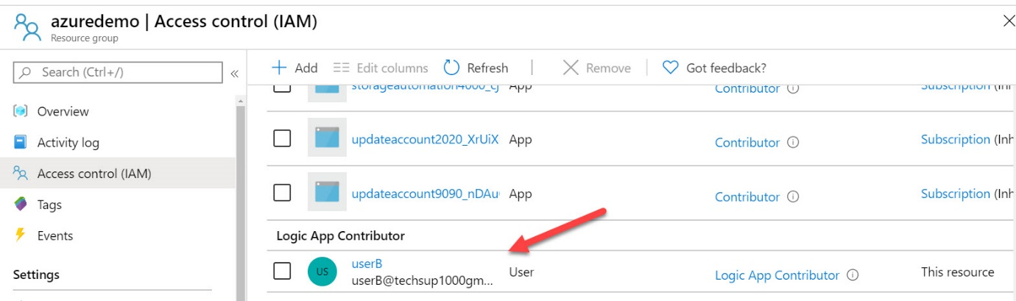

Next go ahead and log in as the user , in this case userB@techsup1000gmail.onmicrosoft.com

Go ahead and click on Create a resource

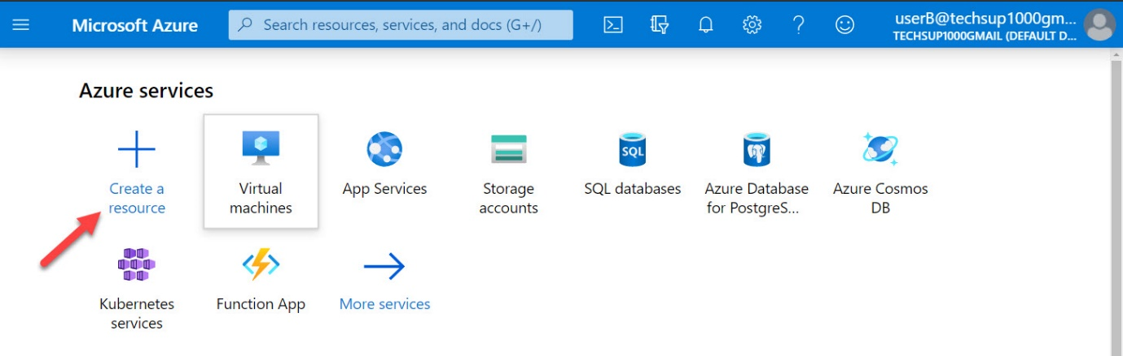

In the marketplace search for Logic App

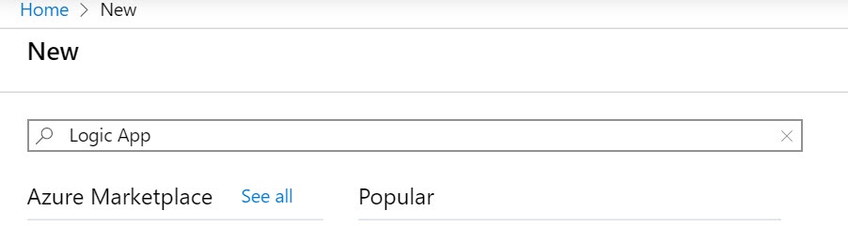

Next go ahead and Create the Logic App

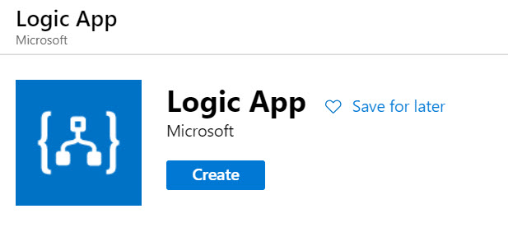

Provide the details of the Logic App

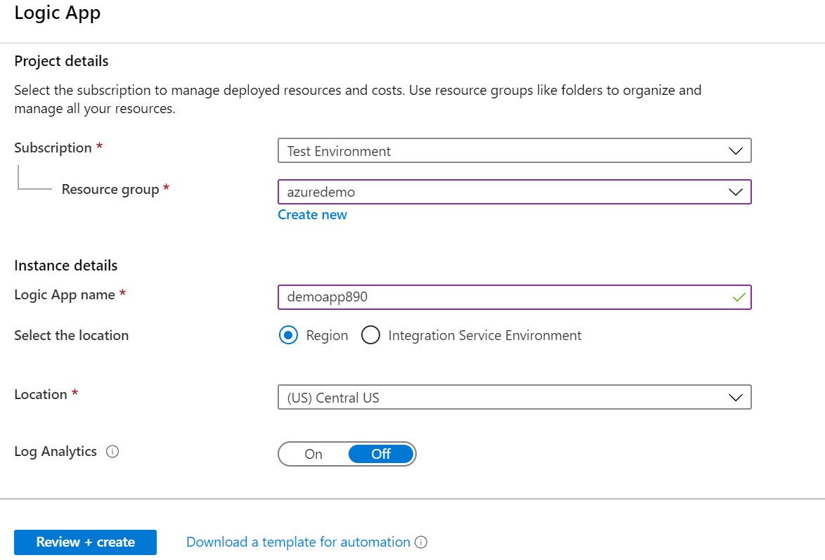

Go ahead to Review +  create and create the Logic App

**Logic App Reader**

This only allows to read, enable, and disable logic apps, but not edit or update them

**Security Read**

This role is meant for Azure Security Center. Sometimes this gets confused with giving access to users , or allowing high privileged access for users. But this is not the case.

This role allows to view recommendations and alerts, view security policies, view security states in Azure Security Center.

But here you cannot make changes in Azure Security Center.

**Security Admin**

This role allows one to view security policies, view security states, edit security policies, view alerts and recommendations, dismiss alerts and recommendations in Azure Security Center